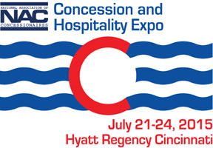

NAC President’s Expo Scholarship Application

Purpose: Founded by then-NAC President Maria Angles, ECM, with an initial donation in 2009, the President’s Convention Scholarship Fund was created to provide a scholarship package each year to the Concession & Hospitality Expo. The Fund will continue through donations and proceeds from the NAC Silent Auction and the NAC Run/Walk.

The Scholarship Package includes:
- Full registration to the Concession & Hospitality Expo;
- Three night’s hotel accommodations at the NAC host hotel;
- A stipend of up to $300 to be used for transportation to the convention location.

Those who will qualify for the Expo Scholarship will:
- Be a current dues-paying member in good standing of NAC;
- Have been in the concessions industry for five years or less;
- Have never attended an Concession & Hospitality Expo;
- Write a short essay stating why they would like to and should be given consideration for the scholarship.
Application deadline date is May 31st, 2015. Please email application to info@NAConline.org, fax to 312.236.7809, or mail to NAC, 180 North Michigan Avenue, Suite 2215, Chicago, IL 60601
Phone 312.236.3858.

Name
Title
Company
Address
City State Zip
Phone Fax
Email:
Job responsibilities:
Number of years in concessions industry_______
Please include a short essay: why you should and would like to receive one of the NAC President’s Expo Scholarships. (Use separate page for essay.)

