NAC Joe Chabot Memorial Expo Scholarship Application

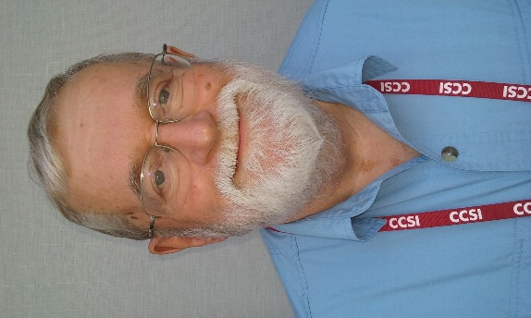
Purpose: Founded in honor and memory of NAC Board member Joe Chabot, who passed away unexpectedly on August 4, 2015. The Scholarship will allow an NAC member to attend the full Concessions & Hospitality Expo with hotel and airfare included.

The Scholarship Package includes:
- Full registration to the Concession & Hospitality Expo;
- Three night’s hotel accommodations at the NAC host hotel;
- A stipend of up to $300 to be used for transportation to the convention location.

Those who will qualify for the Expo Scholarship will:
- Be a current dues-paying member in good standing of NAC;
- Have been in the concessions industry for five years or less;
- Have never attended an Concession & Hospitality Expo;
- Write a short essay stating why they would like to and should be given consideration for the scholarship.
Application deadline date is May 31st, 2016. Please email application to info@NAConline.org, fax to 312.236.7809, or mail to NAC, 180 North Michigan Avenue, Suite 2215, Chicago, IL 60601
Phone 312.236.3858.

Name
Title
Company
Address
City State Zip
Phone Fax
Email:
Job responsibilities:
Number of years in concessions industry_______
Please include a short essay: why you should and would like to receive one of the NAC Joe Chabot Memorial Expo Scholarship. (Use separate page for essay.)

