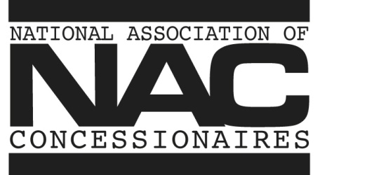
February 29, 2016
Dear NAC Member:
The Mickey Warner Award is bestowed upon an individual each year by NAC to recognize leadership and significant accomplishments in the non-theatre concession industry. The award honors the late Mickey Warner, the father of the NAC Concession Manager Certification Program and one of the greatest innovators and educators of the concessions industry. Past recipients include: Shelly Feldman of Shelly Feldman Associates (2002), Walter Dunn of the Coca-Cola Company (2003), Frank Liberto of Ricos Products Company (2004), Jeremy M. Jacobs of the Delaware North Companies (2005), Chris Bigelow of Bigelow Companies (2006), Phil Noyes of Proof of the Pudding (2007), Ken Young of Ovations Food Service (2008), Charlie Cretors of C. Cretors and Company (2009), Gary Horvath of Ovations Food Service (2010), J. C. Evans of Gold Medal Products (2011), Larry Etter of Malco Theatres (2012),Terry Conlon of the University of Illinois (2013), Gary Wattie of Centerplate (2014) and Dan Kroeger of Gold Medal (2015).

We are requesting the NAC membership nominate candidates for the 2016 award which will be presented at the NAC Concession & Hospitality EXPO July 21 in Minneapolis.

Mickey Warner Award Nomination Form

Criteria: Active involvement in NAC, providing positive leadership direction, significant contributions to the development, education, quality and professionalism of the concessions/hospitality industry, significant accomplishments and longevity to the non-theatre concessions industry and current involvement in non-theatre concessions at the executive level.

Name of Nominated Individual _________________________________________________________

Company ___________________________________________________________________________

NAC Accomplishments/activities ________________________________________________________

Industry Segment _____________________________________________________________________

Management Position _________________________________________________________________

Years Involved in Industry ______________________________________________________________

Deadline: March 14, 2016 Fax: 312 236 7809 or email: dborschke@naconline.org

